Mohammad Abdulmuttaleb (MoeTaleb): Social Media User since '99 (Certified since '10)
MoeTaleb@newegyptconsulting.com | Mobile: 01224317075 | eg.linkedin.com/in/moetalebegypt | Born 1984 in Minufiya | Married

Education @ Arab Academy for Science, Technology and Maritime Transport (AASTMT)
Master Degree | Business Administration (MBA; English) | Excellent GPA 3.44/4 Aug 2009
Bachelor Degree | Electronics & Communications Engineering | Excellent GPA 3.9/4 Jun 2006

Work Experience
Digital Marketing Team Lead & Social Media Strategist/Trainer Obour Buildings, Cairo
New Egypt Consulting; Online media & advertising company 2011 till now

- Monginis F&B Brand (Repeated client): o Increasing online dollar revenues from outside Egypt by 133% per month
o Increasing E-Commerce sales by 10X without ads and 13000% growth (yes ☺) with Ramadan ads
o Restructuring E-Commerce & digital marketing (Augmented reality, content marketing & integration with 60+ shops).
- Dubai-based Multiples Group: Intensive Facebook & social media training to Cairo teams including Alef Bookstores
- Riyadh-based CXTransformers: Social media & online business auditing for one their clients (education sector)
- UK-based IIDR: Online advertising campaign and website revamping consultations
- Saudi-based mobile VAS company OTS (Now Unifonic): Managing and executing online advertising campaigns:
  - 64% of clients’ inquiries (and 17% of sales) were from Google AdWords/Facebook ads
  - 2011 Q4: 50% increase in New Visits and 18% increase in traffic from Facebook
- Anoud Recruitment: Facebook marketing and advertising training
- Sigma Electronics Industrial Factory: Digital marketing assessment for exporting opportunities
- BadrIT Company: Online PR strategy & mobile tweaks for listening tool TweetElect (Featured in Wamda, WPost, etc)
- Beltone Egypt: SEO optimization and social media optimization to generate tens of thousands of pounds quarterly
- My viral content on Tamer Hosny's fake Twitter followers got featured in Yahoo!, ElFagr, Akhbarak, AlBawaba & FilFan.

Social Media Consultant (Reporting to UNIC Director) Garden City, Cairo
United Nations Regional Media Office; International Organization Jan 2016 till Feb 2016

- Working with UNHCR, UNDP & UK government on London conference agenda online supporting Syria in parallel to the regional press conference (Both Arabic & English Twitter hashtags were trending in Egypt)
- Working with the Arab League on Mostakbalna social media initiative on fighting terrorism & empowering youth supporting also UN Sustainable Development Goals.
Mohammad Abdulmuttaleb (MoeTaleb): Social Media User since '99 (Certified since '10)
MoeTaleb@newegyptconsulting.com | Mobile: 01224317075 | eg.linkedin.com/in/moetalebegypt | Born 1984 in Minufiya | Married

Digital Marketing Communications Manager (Reporting to UK-based CEO) Roxy, Cairo
Awakening Worldwide and Awakening Records; UK-based Media Company 2013 till 2015

- Founded digital media department (Online media strategy, hiring 5+ team members & E-Commerce operations)
- Worked with UN organizations (i.e. UNHCR, Human Appeal, etc) on mutual projects. One tweet was the 3rd largest source of donation transactions and the 3rd largest source of traffic to UNHCR website. Facebook post was the 5th largest driver
- Led the growth of social media platforms (88% YOY growth - more than $100,000 increase in revenues): 1.5 Million YouTube subscribers, 4 Million Twitter followers, 35 Million Facebook fans, hundreds of thousands of Instagram followers, SoundCloud listeners, website visitors (Responsible for more than 6 websites including hosting) and email recipients
- Supervised all websites & social media accounts (company and its online shopping portal & artists) + their daily operations
- Led Hamza Namira's Esmanni album team (website development, partnership agreement, video marketing, media communications, social media engagement, E-Commerce sales with Jumia Egypt, etc) – Trending on Twitter & YouTube
- Led #WeAreHome music video crowdfunding project team collecting $26,117 (119% of target) within 1 month
- Led the $25,000+ project Awakening Talent Contest 2013 (Video & art-work production, YouTube support, website development, media bloggers, judging committee [Maher Zain, Hamza Namira, etc] & live streaming announcements)
- Managed and participated in content & social media engagement strategies for different campaigns and activities online (including $10,000 project of kids album animation videos, Sira mobile application, etc)
- Integrated digital marketing communications to achieve 50% YOY sales growth on Awakening Store (by proper search engine optimization, worldwide shipping, utilizing warehouses in UK, US, Dubai and Egypt, adding digital downloads, etc)
- Increased traffic conversions & SEO visibility for Awakening Store E-Commerce portal (2012 visits from Facebook & Twitter jumped from 10% of all H1 visits to 30% @ H2).
- Drafted the winning submission application highlighting social media & the Awakening Talent Contest where our CEO received Media/Entertainment award from HRH Sheikh Rashed Al Maktoum PM of UAE and ruler of Dubai
- Co-led web development mega project for Awakening portals and mobile app (ongoing project)
- Executed & planned Facebook/AdWords/YouTube/PPC ads of more than $10,000 with measurable successful ROI
- Experienced in using HootSuite, Google Apps, AdSense & Analytics, MailChimp, Keyword Planner & other cloud SaaS
- The only employee from Cairo office to be interviewed in Awakening VIP Magazine celebrating 15 years
Associate Product Manager (Reporting to General Manager) Nasr City, Cairo
E-Nor; US-based web development and Google Analytics company 2010 till 2011
- Analyzed software modules life cycle including analysis, project documents, user experience mockups, execution, pricing & launching → Result: new module 41% of 2010 H2 DNN sales
- Supported sales operations (web campaigns, competitor analysis & 1st level customer service)
- Handled a project for online portal for kids (100+ flash games) including the vendor relations, documentation, ActionScript outsourcing and studio recording.
- Worked as solution architect & business analyst: Tax software – mobile applications (Mobile Taxi)
- Led pre-sales initiatives: Shorouk publishing, ABC Bank, Resala NGO and real estate clients
- Participated in some business development meetings for mobile banking project (M-Currency)
- Saved $4,000 by modifying web-based project requirements

Business Developer (Reporting to General Manager) Obour Buildings, Cairo
Smart IT Group; Web solutions company & TEData reseller 2009 till 2010
- Assessed web-conferencing providers [+meetings/conference] (WebEx, Dimdim, etc) securing 2 contracts from US

E-Marketing Specialist Smouha, Alexandria
NEC; Recruitment and career counseling company 2009 till 2009
- Advised job seekers for CV & job-hunting (Read my article in Shorouk Newspaper)
- Conducted marketing campaigns (Facebook, HTML-based email marketing campaigns, Waseet Ads & Syndicate Clubs)
- Developed the career tips and job board blog & website carcareercairo.newegyptconsulting.com

Alexandria Branch Manager (Reporting to General Manager) Roshdy, Alexandria
Beltone Egypt (Al-Arkan Co. for Hearing Aids; family-owned business) 2006 till 2009

- Activated existing sales channels (67% increase in branch office sales 2007; computerized activities)
- Attracted new sales accounts (10+ key accounts 07/08; doubling sales force 07/08)
- Improved sales quality (Insurance RFPs, average allowed discounts 2.8%@07 down from 5.7%@06)
- Hunted business opportunities [Competitor analysis, ads, website, Sudan exporting feasibility, etc].
- Managed distributors' contracts & accounts as well as branch matters including coordinating with Ministries of Defense & Health
- Co-coached technicians, accountant & sales team and indoor sales staff [5 employees].
- Managed process of relocating to a new office from negotiations to final transfer (legal, authorities, architecture, etc)
- Arranged for company participation in the international ENT conference including logistics preparations (i.e. hotel reservations, etc)

YouTube Certified (Since 2014) | Google AdWords Fundamentals Exam (Passed 2015)
Social Media Marketing Certified (Since 2010) | Email Marketing Certified (Since 2010)

Arabic Language Native | English Language Excellent (573 in p-TOEFL)

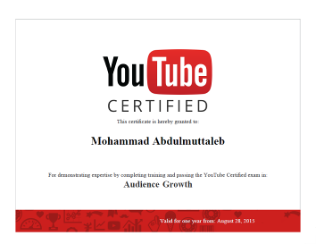 | 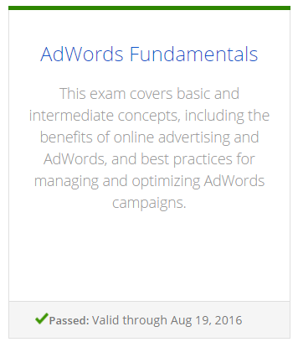
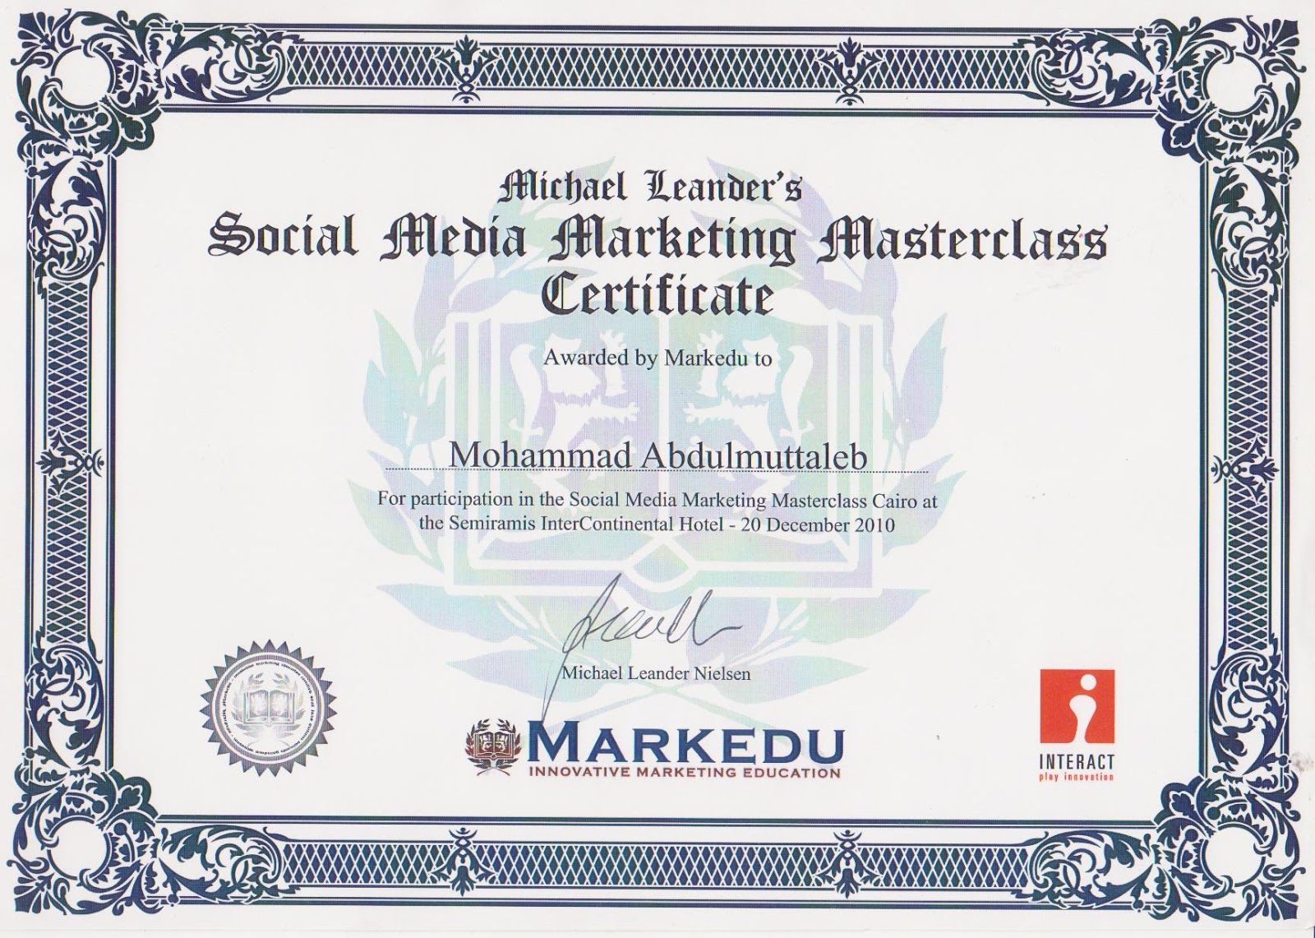 |  | 

